AMALFI

Lady Cardigan+Top

Back:
Cast on 59 (63) cm sts. K 37 (39) cm in stst and
shape armholes: Dec 2 times 2 sts and 4 times 1 sts in every alt row. Cast of if your work measure 58 (61) cm.
Front left:
K reciprocal the same as the right part.
Front right:
Cast on 30 (33) sts. K in stst 32 (35)cm.
Shape neckline: Dec 3 times 1sts every alt row afterwards
9 times 1 sts in every 4th row. Shape armholes: If your work measure 58 (61) cm cast off rem sts 10 (13).
Size: 38 +(42)
Material:
10 (11)ball AMALFI,
7 mm needle

6 mm crochet hook
Tension:
12 sts + 18 row = 10 cm
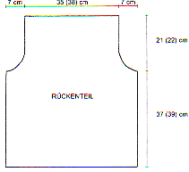
Sleeves:
Cast on 26 (28) sts. Inc alt in each 6 o 8 row,10 times 1 sts, until your work measure 42 cm.
Shape armpits: Dec 2 times 2 sts, 8 times 1sts and 2 times 2 sts every alt row. Cast off rem 14 (16) sts.
Making up:
Sew together all Parts. And if you like , crochet all edge with double crochet sts or crab sts.
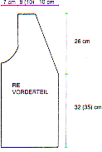
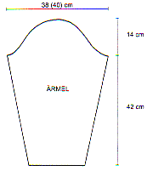
back
front
sleeves

ART YARN from Angel Yarns
SWISS-DESIGNED LANARTUS
Abrevation:
K = knit
Sts = stitch
Inc = increasing
rev = reversing
Dec = decreasing
alt = alternate
Stst = stocking stitch
cont = continue
Rib = knit1 purl 1
folls = following
mm = millimetre
cm = centimetre



